Lab 1: Static VLAN Configuration and Trunking
Objective
The overall objective of this laboratory exercise is to gain experience with the basic steps for configuring a static VLAN on a Cisco switch. In this exercise you create two VLANs, Finance and Office, and assign switchports to each VLAN. You need to configure the switch (SW1) so that server (PC3) is assigned to VLAN 1, computer (PC2) is assigned to VLAN 2, the Finance VLAN, and computer (PC1) is assigned to VLAN 3, the Office VLAN. The IP addresses used in this exercise are configured as part of a 192.168.X.X network. Configure switches and the computers to operate in the network using the IP addresses, subnet mask, and gateway address specified in Table 1 and 2. You gain an understanding of the following:
1. Operating in the Cisco Privileged mode
2. Configuring and assigning names to the VLANs
3. Assigning ports to the VLANs
4. Steps to verify port assignments
5. Troubleshooting the switch interface and VLAN assignments

Topology
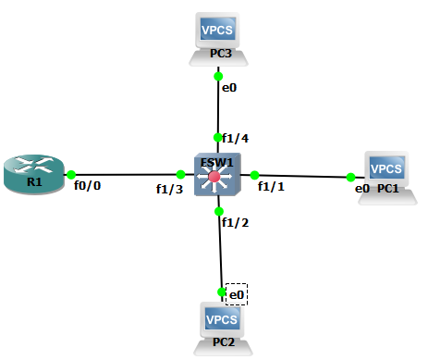enable
Figure 1:The Network Topology for This Lab
Key Concepts
The following concepts, terms, commands, and steps should be mastered in this exercise.
1. Enter the switch’s privileged EXEC mode (switch#).
2. Configure the IP address for the VLAN 1 interface on your switch.
3. Use the no shut command to enable the VLAN interface.
4. Use the sh vlan-switch command to verify that the interfaces have been configured.
5. Use the ping command to verify network connectivity.
6. Verify the entries into the switch’s mac address table.
7. Configure the switch port settings.
8. Configure the default-gateway for the switch.
9. Configure the VLAN interfaces.
10. Use the show vlan-switch command to verify that the VLANs have been created.
11. Assign ports to the VLANs.
Reference Tables
For convenience, Table 1 provides the IP addresses and masks for all the necessary interfaces to complete this lab.
Table 1: The IP Addresses, Subnet Masks, and VLAN Assignments for Lab 1
Computer/Server – SW1 | IP Address | Subnet Mask | Gateway Address
PC1 | 192.168.1.1 | 255.255.255.192 | 192.168.1.62
PC2 | 192.168.2.1 | 255.255.255.192 | 192.168.2.62
PC3 | 192.168.3.1 | 255.255.255.192 | 192.168.3.62
VLAN1 | 192.168.1.61 | 255.255.255.192 | 192.168.1.62
R1 Fa 0/0.1 | 192.168.1.62 | 255.255.255.192
R1 Fa 0/0.2 | 192.168.2.62 | 255.255.255.192
R1 Fa0/0.3 | 192.168.3.62 | 255.255.255.192
R1 Fa 0/0.1 | 192.168.1.62 | 255.255.255.192
Detailed Lab Steps
In the following tasks, you must demonstrate your knowledge of configuring computer networks. Each task specifies a particular network setting you are required to input. You are required to document the command(s) used to accomplish each task.
Task #1
1. Configure the IP address for VLAN1. The IP address is provided in Table 1. Enable the VLAN1 interface. List the command sequence required to accomplish these tasks. Indicate both the prompt and the command.

2. Configure the IP addresses for computers PC1 and PC2, for PC3, and for Router R1.. List the command sequence required to accomplish this task.

3. Use the command that displays the current VLAN interface information.

4. Which ports currently belong to the default VLAN?

5. How many VLANs are set up by default on the switch? List the VLANs.

6. Create two VLANs: VLAN2 (Finance) and VLAN3 (Office). List the command sequence required to create the VLANs, and assign names to each VLAN.

7. Verify that the two new VLANs have been created. List the command sequence required to accomplish this task.

8. What ports are currently assigned to VLANs 2 and 3?

9. Issue the commands the assign the ports connecting S1, PC1, and PC2 to their respective VLANs.

10. Use the proper command to verify that the switchports have been properly assigned. List the command sequence required to accomplish this task.

11. Use the command to list the MAC addresses learned by SW1. Which interfaces are associated with the MAC addresses of PC1, PC2, and PC3 and which VLAN number is listed for each entry.

12. Create the trunk connection from switch Fast Ethernet 0/3 interface to the router.

13. Configure the Router R1 to support trunking and inter-VLAN routing. This requires that the Fast Ethernet 0/0 and related subinterfaces be configured.

14. Now that VLANs and trunking have been configured, verify that PC1, PC2, and S1 can ping each other. List the commands used to verify this.

Task #2: Configuration List
The following is a partial list of the items displayed when you issue the command show running-configuration [sh run]on a switch. Your task is to define each item and its purpose. You might need to go to Cisco.com to look up what each of these commands means.
1. switchport mode trunk

2. no aaa new-model

3. encapsulation dot1q 1 native

4. encapsulation dot1q 2

5. switchport mode access

6. switchport access vlan 2

7. ip default-gateway 192.168.1.62

8. line vty 0 4

9. line vty 5 15

